Terminal Outputs

Jorge Alvarez  
A01632080

# Análisis de errores pylint

## hotel.py

## Customer.py

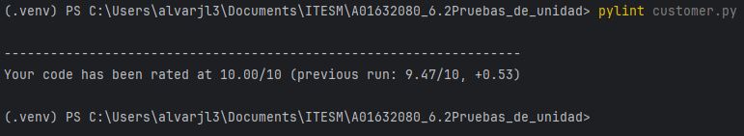

## Reservation.py

## Test_hotel.py

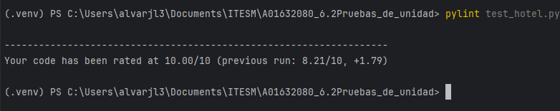

## Test_customer.py

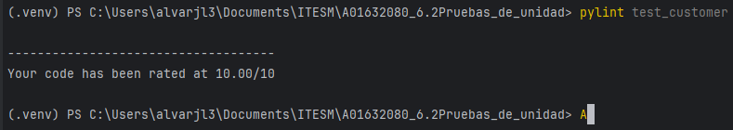

## Test_reservation.py

# Análisis de errores flake8

## hotel.py

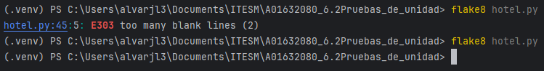

## Customer.py

## Reservation.py

## Test_hotel.py

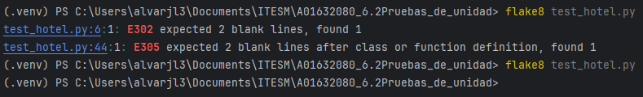

## Test_customer.py

## Test_reservation.py

Casos de prueba y cobertura

